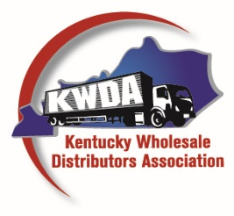
RON MORRIS, EXECUTIVE DIRECTOR
7014 Hughes Avenue
Crestwood, KY 40014
Tel: 502.423.9280 - FAX: 502.243.9398
ron.kwda@gmail.com

APPLICATION FOR MEMBERSHIP

TO THE BOARD OF DIRECTORS: We hereby make application for membership in the Kentucky Wholesale Distributors Association. If accepted, we agree to conform to the By-Laws of the said Association as they now are or as they may be hereafter amended; support its objectives and interests; and pay the dues established by the Board of Directors. We hereby agree that, as a member of the Association, we will actively promote the Association and its principles, and that we will actively participate in the Association’s programs and activities, and in furthering the ideals and mission of the Association.
Please Print

Company
Address:
City State Zip
Phone: FAX:
Cell:
Email:
Title:
Signature:

THE BY-LAWS PROVIDE: Any person, firm or corporation engaged in the marketing, distributing or selling of tobacco, candy, and related productions of any kind or character at wholesale is eligible to become a member of this Association.

Any individual, partnership, corporation or entity who supplies the tobacco or candy industry, or is allied to said industry, may become an Associate Member of the Association by making a formal application in writing to the Board of Directors. No Associate Member shall have the right to vote at any meeting of the members of the Association or to hold an elective office.

CHECK CLASS OF MEMBERSHIP APPLYING FOR

REGULAR MEMBER (Also Check Volume Area) - Anyone who sells tobacco or candy other than at retail.
KWDA fiscal year for annual dues is May 1 through April 30.

Up to $5,000,000 volume annually $1,000 / year Associate Member (Class I) Candy Tobacco & other
$5,000,000 to $10,000,000 annually  $2,000 / year manufacturers  $500 / year
$10,000,000 and up annually  $3,000 / year Associate Member (Class II) Brokers… $300 / year

